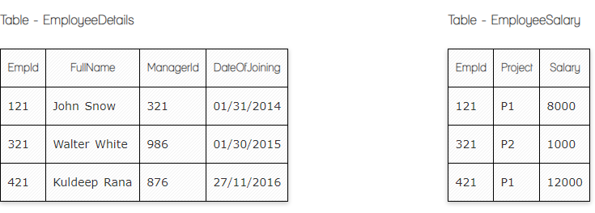

**Write a SQL query to fetch the count of employees working in project 'P1'.**

**Answer:**

SELECT COUNT(EmployeeID)

FROM EmployeeSalary

WHERE Project=**'P1'**

**Write a SQL query to fetch employee names having salary greater than or equal to 5000 and less than or equal 10000.**

**Answer:**

SELECT EmployeeDetails.FullName,EmployeeSalary.Salary

FROM EmployeeDetails

INNER JOIN EmployeeSalary

ON EmployeeDetails.EmployeeId= EmployeeSalary. EmployeeId

where salary between 1000 and 5000

**Write a SQL query to fetch count of employees sorted by project's count in descending order.**

**Answer:**

SELECT EmployeeID , Count(EmployeeID)

FROM EmployeeSalary

GROUP by Project

ORDER BY Count(EmployeeID) desc

**Write a query to fetch employee names and salary records. Return employee details even if the salary record is not present for the employee.**

**Answer:**

SELECT EmployeeDetails.FullName,EmployeeSalary.Salary

FROM EmployeeDetails

**LEFT** JOIN EmployeeSalary

ON EmployeeDetails.EmployeeId= EmployeeSalary. EmployeeId

**Write a SQL query to create an empty table with ‘Test’ name.**

**Answer:**

CREATE TABLE Test

**Write a SQL query to delete an empty table with ‘Test’ name.**

**Your Answer:**

DROP TABLE Test

**Ques.7. Write a SQL query to fetch all the Employees details from EmployeeDetails table who joined in Year 2016.**

**Answer:**

SELECT*FROM Employees details WHERE Date of joininglike “%2016”

**Write a SQL query to insert new record to the EmployeeDetails table with any data.**

**Answer:**

INSERT INTO EmployeeDetails(City)

Value(Yerevan)

**Write a SQL query to update EmployeeSalery table with setting Salary to 2000 for Project P2.**

**Answer:**

UPDATE EmployeeSalary SET Salary=2000 WHERE Project=’P2’

**Write a SQL query to right join both tables and draw the results.**

**Answer:**

SELECT column_name(s)  
FROM EmployeeDetails  
RIGHT JOIN EmployeeSalary  
ON EmployeeDetails.column_name = EmployeeSalary.column_name